**Bài 2: Given a list of integer numbers: 2, 1, 10, 6, 3, 8, 7, 13, 20.**

-Draw the binary search tree:

-Draw the binary search tree after inserting values: 14, 0, 35:

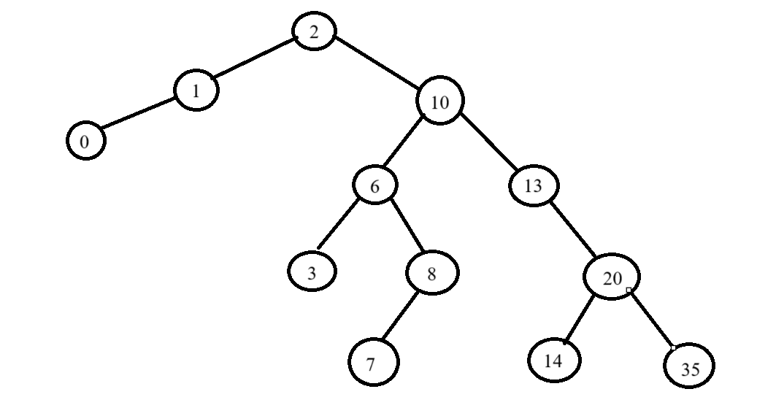

-Draw the binary search tree after deleting: 6, 13, 35:

**Bài 3: Given a list of integer numbers: 2, 1, 10, 6, 3, 8, 7, 13, 20.**

-Draw the heap tree:

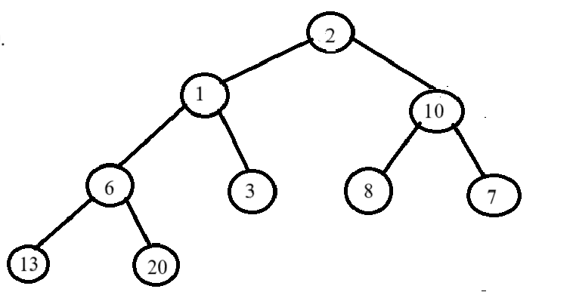

-Draw the heap tree after inserting values: 14, 0, 35:

-Draw the heap tree after deleting: 6, 13, 35:

Bài 4: Dãy số: 4, 12, 14, 7, 19, 2, 18, 9, 6, 8 (S1)

-Insert elements from S1 to a binary search tree one by one and draw the binary search tree after each step.

